Block Shipment Management Tracking System

Pushpraj Chaudhary  
Department of Information Science and Engineering   
JAIN(Deemed-to-be University)  
Bengaluru, India  
[20btris063@jainuniversity.ac.in](mailto:20btris063@jainuniversity.ac.in)

Suraj Kr Sah  
Department of Information Science and Engineering   
JAIN(Deemed-to-be University)  
Bengaluru, India  
[20btris057@jainuniversity.ac.in](mailto:20btris057@jainuniversity.ac.in)

Prabin Kr Mahato  
Department of Information Science and Engineering   
JAIN(Deemed-to-be University)  
Bengaluru, India  
[20btris073@jainuniversity.ac.in](mailto:20btris073@jainuniversity.ac.in)

Sujit Kr Yadav  
Department of Information Science and Engineering  
JAIN(Deemed-to-be University)Bengaluru, India  
[20btris072@jainuniversity.ac.in](mailto:20btris072@jainuniversity.ac.in)

Mrittika Dewanjee  
Department of Information Science and Engineering   
JAIN(Deemed-to-be University)  
Bengaluru, India  
[20btris034@jainuniversity.ac.in](mailto:20btris034@jainuniversity.ac.in)

***Abstract***— **The report delves into the revolutionary potential of Blockchain Shipment Management Tracking Systems within the logistics and supply chain domain. By harnessing the decentralized and transparent attributes of blockchain technology, this system seeks to redefine conventional shipment tracking methodologies. Its fundamental components encompass a distributed ledger, consensus mechanisms, and smart contracts, collectively ensuring a seamless, real-time, and tamper-resistant tracking framework across the entire supply chain.**

**The system's advantages are multi-faceted. It introduces heightened transparency by providing all stakeholders with concurrent access to identical information, mitigating information asymmetry prevalent in traditional tracking systems. Moreover, its intrinsic tamper-resistant nature significantly diminishes the risk of fraudulent activities, thereby establishing a more secure and trustworthy environment for tracking and managing shipments. Automation is facilitated through smart contracts, streamlining processes, minimizing manual interventions, and ultimately enhancing the overall efficiency of shipment management.**

**Examining real-world applications, case studies such as IBM Food Trust and collaborative efforts between industry giants like Walmart and DHL showcase successful implementations of blockchain in logistics. Despite the potential, the report acknowledges challenges in integration with existing systems, navigating complex regulatory landscapes, and the necessity for comprehensive education and training of stakeholders.**

**Looking forward, the report envisions a future where Blockchain Shipment Management Tracking Systems become a standard in the logistics industry, fostering collaboration, trust, and efficiency among participants in the global supply chain. While acknowledging challenges, the report contends that businesses embracing blockchain solutions are poised to gain a competitive advantage in the dynamic and evolving landscape of global trade.**

Keywords— Block Chain

I. INTRODUCTION

The global logistics and supply chain industry is undergoing a paradigm shift with the introduction of transformative technologies, and at the forefront of this evolution stands the Blockchain Shipment Management Tracking System. Traditionally, the supply chain has grappled with inefficiencies, opacity, and susceptibility to fraud, necessitating innovative solutions to meet the demands of an increasingly interconnected and complex global trade landscape. Blockchain technology, renowned for its decentralized and transparent nature, emerges as a potent catalyst for addressing these challenges and ushering in a new era of efficiency, security, and trust in the realm of shipment management.

1.1 Background:

The backdrop against which this system is introduced is one marked by intricate supply chain networks, where the movement of goods is not only a physical process but also intricately tied to the exchange of vast amounts of information across a multitude of stakeholders. The conventional methods of tracking shipments have often proven inadequate in providing real-time visibility, fostering transparency, and ensuring the integrity of data throughout the supply chain journey.

1.2 Objectives:

The primary objective of the Blockchain Shipment Management Tracking System is to transcend these limitations. By harnessing the decentralized and tamper-resistant characteristics of blockchain, this system aims to create an environment where stakeholders, from manufacturers to end-users, can seamlessly access and trust a single, immutable source of truth regarding the status and location of shipments. In doing so, the system seeks to enhance transparency, reduce the risk of fraudulent activities, and streamline operational processes.

1.3 Rationale:

The rationale behind the adoption of blockchain in shipment management is rooted in its ability to provide a single version of truth accessible to all participants, eliminating the need for intermediaries and central authorities. The immutability of blockchain records ensures that once information is entered, it cannot be altered or tampered with, providing an unparalleled level of data integrity. As a result, the technology holds the promise of not merely optimizing existing processes but fundamentally reshaping the way stakeholders interact within the supply chain ecosystem.

In the subsequent sections of this report, we will delve into the inner workings of the Blockchain Shipment Management Tracking System, exploring its key components, mechanisms, and the tangible benefits it offers. Through the examination of real-world case studies, challenges, and the anticipated future trajectory, we aim to provide a comprehensive understanding of the transformative potential that blockchain brings to the forefront of global shipment management.

II. LITERATURE REVIEW

The integration of blockchain technology into the realm of shipment management has garnered significant attention from researchers and industry experts alike. This literature review synthesizes existing knowledge, explores key findings, and identifies trends and gaps in the current understanding of Blockchain Shipment Management Tracking Systems.

1. Blockchain Technology Overview:

Blockchain, as a decentralized and distributed ledger technology, has been widely recognized for its potential to revolutionize various industries. In the context of shipment management, its core attributes—decentralization, transparency, and immutability—have become central focal points in discussions surrounding the optimization of global supply chains.

2. Transparency and Traceability:

One of the primary advantages emphasized in the literature is the ability of blockchain to enhance transparency and traceability in the supply chain. Through a shared and decentralized ledger, all stakeholders gain real-time visibility into the movement and status of shipments, mitigating information asymmetry and fostering a more collaborative ecosystem.

3. Trust and Security:

Several studies underscore the role of blockchain in building trust among participants in the supply chain. The tamper-resistant nature of blockchain ensures the integrity of shipment data, reducing the risk of fraud and unauthorized alterations. Trust, a critical element in supply chain relationships, is thereby strengthened.

4. Smart Contracts and Automation:

The literature consistently highlights the role of smart contracts in automating and streamlining various processes within shipment management. Smart contracts execute predefined actions when specific conditions are met, reducing the need for manual interventions and expediting the overall flow of goods.

5. Real-World Case Studies:

Examinations of real-world implementations, such as IBM Food Trust and collaborations between major corporations like Walmart and DHL, serve as empirical evidence of the effectiveness of blockchain in enhancing supply chain visibility, traceability, and collaboration. These case studies provide insights into challenges faced and lessons learned during the adoption of blockchain in large-scale logistics operations.

6. Challenges and Concerns:

While the potential benefits are evident, the literature also acknowledges challenges associated with the implementation of Blockchain Shipment Management Tracking Systems. Integration with existing systems, regulatory compliance, and the need for education and training emerge as recurrent themes, underscoring the complexity of transitioning to blockchain-based solutions.

7. Future Directions:

The literature points towards a promising future for blockchain in shipment management. As technology matures, researchers and practitioners anticipate increased adoption, standardization, and further innovations. The potential for blockchain to serve as a foundational technology for a secure, efficient, and collaborative global supply chain ecosystem is a recurring theme in forward-looking discussions.

8. Conclusion:

In conclusion, the literature review underscores the transformative potential of integrating blockchain into shipment management. The advantages of transparency, trust, and automation are evident, supported by real-world case studies. However, challenges and concerns highlight the need for a holistic approach to implementation. As the field continues to evolve, further research is warranted to address emerging complexities and optimize the benefits of Blockchain Shipment Management Tracking Systems for diverse supply chain scenarios.

III. ANALYSIS

The implementation of Blockchain Shipment Management Tracking Systems represents a disruptive shift in the logistics and supply chain landscape. Below is a detailed analysis of various aspects, including technological components, benefits, challenges, and potential future developments.

1. Technological Components:

Distributed Ledger:

• Strengths: The decentralized ledger ensures that all participants in the supply chain have real-time access to a single, immutable source of truth. This fosters transparency and mitigates the risk of discrepancies in information.

• Challenges: The transition from centralized systems to distributed ledgers may pose integration challenges. Additionally, the scalability of blockchain networks needs careful consideration as the volume of transactions increases.

Consensus Mechanism:

• Strengths: Consensus mechanisms, such as proof-of-work or proof-of-stake, guarantee agreement on the state of the ledger, enhancing the security and reliability of the system.

• Challenges: Different consensus mechanisms have varying levels of energy consumption and speed. Striking a balance between security and efficiency remains a consideration.

Smart Contracts:

• Strengths: Automation through smart contracts streamlines processes, reducing the need for intermediaries and enhancing operational efficiency.

• Challenges: The complexity of defining and implementing smart contracts requires careful consideration. Code vulnerabilities and legal implications must be addressed.

2. Benefits:

Transparency:

• Strengths: The transparency provided by blockchain ensures that all stakeholders have access to the same, real-time data. This mitigates information asymmetry and fosters collaboration.

• Challenges: Striking a balance between transparency and data privacy is crucial. Ensuring that sensitive information is appropriately protected is an ongoing concern.

Reduced Fraud:

• Strengths: The immutability of blockchain records reduces the risk of fraudulent activities, ensuring the integrity of the shipment data.

• Challenges: While blockchain provides a robust defense against external fraud, internal threats and vulnerabilities within the system must be continually addressed.

Efficiency Gains:

• Strengths: Automation through smart contracts reduces manual interventions, expediting processes and reducing the likelihood of errors.

• Challenges: The initial investment in transitioning to blockchain systems and potential resistance to change within organizations may offset immediate efficiency gains.

3. Challenges and Considerations:

Integration:

• Analysis: Integrating blockchain with existing systems is a complex process that requires meticulous planning. Compatibility issues and potential disruptions during the transition must be carefully managed.

Regulatory Compliance:

• Analysis: Adhering to local and international regulations is paramount. The dynamic nature of regulatory frameworks requires ongoing monitoring and adaptation.

Education and Training:

• Analysis: Ensuring that all stakeholders are well-versed in blockchain technology is essential for successful implementation. Education and training programs must be comprehensive and ongoing.

4. Future Outlook:

Adoption Trends:

• Analysis: The literature and real-world case studies suggest a growing trend toward the adoption of blockchain in logistics. As technology matures and standards emerge, broader industry adoption is anticipated.

Innovation and Evolution:

• Analysis: Ongoing innovations in blockchain technology, such as the development of more energy-efficient consensus mechanisms and advancements in interoperability, are expected to drive further evolution and adoption.

In conclusion, the analysis demonstrates that while Blockchain Shipment Management Tracking Systems offer substantial benefits, the successful implementation requires addressing integration challenges, ensuring regulatory compliance, and prioritizing education. The future outlook is optimistic, with the potential for widespread adoption and continued innovation propelling the logistics and supply chain industry into a new era of efficiency and transparency.

##### IV. design

Designing a Blockchain Shipment Management Tracking System involves careful consideration of the system architecture, user interfaces, and integration points. Below is a detailed design outline for such a system:

1. System Architecture:

Blockchain Network:

• Select a suitable blockchain platform based on the requirements (e.g., Ethereum, Hyperledger Fabric).

• Define the structure of the blockchain network, including nodes for participants like manufacturers, distributors, carriers, and end-users.

Smart Contracts:

• Develop smart contracts to automate key processes, such as updating shipment status, triggering payments, and handling disputes.

• Implement secure coding practices to mitigate vulnerabilities.

Consensus Mechanism:

• Choose an appropriate consensus mechanism based on the desired balance between security and efficiency.

• Consider factors such as scalability and environmental impact.

Distributed Ledger:

• Design the distributed ledger to store key information related to shipments, including origin, destination, timestamps, and status updates.

• Ensure data privacy and encryption mechanisms are in place.

2. User Interfaces:

Web and Mobile Interfaces:

• Develop user-friendly interfaces for web and mobile platforms, catering to various stakeholders.

• Include dashboards for real-time tracking, analytics, and notifications.

User Authentication:

• Implement secure authentication mechanisms, such as multi-factor authentication, to ensure that only authorized users access the system.

• Integrate with existing user management systems where applicable.

Data Visualization:

• Utilize charts, graphs, and maps to visually represent shipment data, enhancing the user's understanding and decision-making capabilities.

• Provide customizable reporting features.

3. Integration Points:

Integration with Existing Systems:

• Plan and execute a phased integration strategy to minimize disruptions.

• Develop APIs or middleware to facilitate communication between the blockchain system and existing ERP, CRM, or other logistics systems.

IoT Integration:

• Integrate IoT devices (sensors, RFID, GPS) for real-time tracking and data input.

• Ensure secure communication between IoT devices and the blockchain network.

Payment and Finance Systems:

• Connect the smart contracts with payment gateways to automate financial transactions based on predefined conditions.

• Ensure compliance with financial regulations.

4. Security Measures:

Encryption:

• Implement end-to-end encryption to secure data during transmission.

• Encrypt sensitive information stored on the blockchain.

Access Control:

• Define and enforce access control policies to restrict user permissions based on their roles.

• Regularly audit and update access controls.

Security Audits:

• Conduct regular security audits to identify and rectify vulnerabilities.

• Engage external security experts for penetration testing.

5. Regulatory Compliance:

Legal Framework:

• Stay informed about relevant local and international regulations governing supply chain and logistics.

• Design the system to capture and report data required for compliance.

Data Privacy:

• Implement features that allow users to control and manage their data in compliance with data protection laws.

• Include consent mechanisms for data sharing.

6. User Training and Support:

Educational Resources:

• Develop comprehensive training materials, including manuals, videos, and tutorials, to educate users on the blockchain system.

• Conduct training sessions for stakeholders.

Customer Support:

• Establish a responsive customer support system to address queries, issues, and provide assistance.

• Implement ticketing or chat systems for efficient issue resolution.

7. Scalability:

Scalability Planning:

• Design the system with scalability in mind to accommodate an increasing number of participants and transactions.

• Consider solutions such as sharding or sidechains.

Performance Monitoring:

• Implement monitoring tools to continuously assess system performance and identify areas for optimization.

• Plan for periodic capacity upgrades as needed.

8. Future Enhancements:

Interoperability:

• Explore opportunities for interoperability with other blockchain networks or legacy systems.

• Stay informed about emerging standards.

AI Integration:

• Evaluate the potential integration of artificial intelligence for predictive analytics, anomaly detection, and optimization.

• Identify areas where machine learning can enhance decision-making.

By meticulously addressing these design considerations, a Blockchain Shipment Management Tracking System can be developed to enhance transparency, security, and efficiency throughout the supply chain. Regular updates, monitoring, and responsiveness to technological advancements will ensure the system remains resilient and adaptable to the evolving needs of the logistics industry.

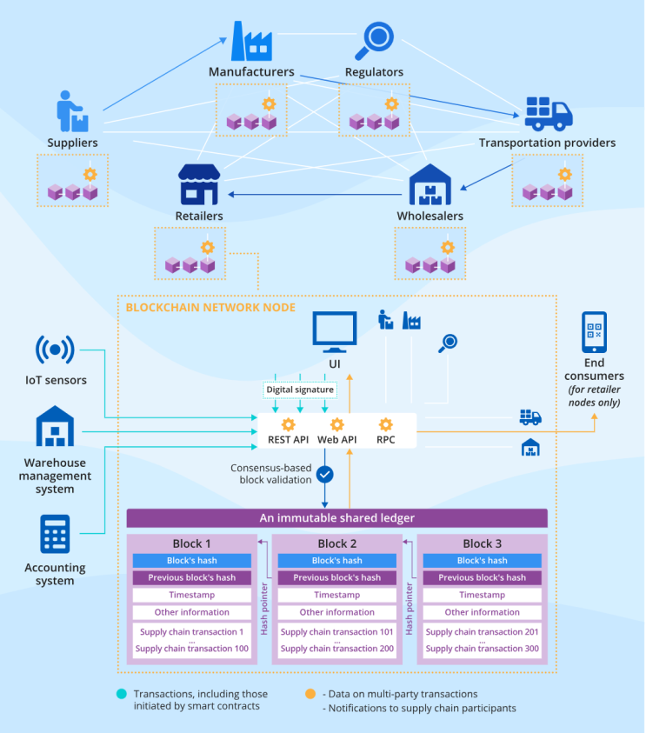

fig :- Architecture diagram of BlockChain Shipment Tracking System

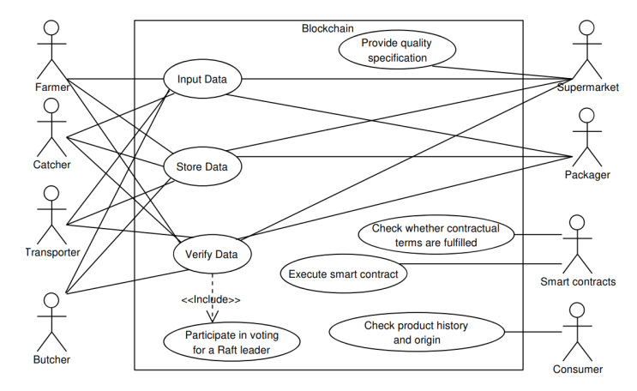

fig : UML diagram of BlockChain Shipment Management Tracking System

Algorithm

# Smart Contract for Shipment Management

# Structure to represent shipment details

struct Shipment {

string origin;

string destination;

string currentStatus;

timestamp deliveryTimestamp;

address sender;

address carrier;

address recipient;

}

# Mapping to store shipment details with a unique shipment ID

mapping (uint256 => Shipment) shipments;

# Event to log shipment status updates

event ShipmentStatusUpdate(uint256 shipmentId, string newStatus, timestamp updateTimestamp);

# Smart contract function to initiate a new shipment

function initiateShipment(uint256 shipmentId, string origin, string destination, address sender, address carrier, address recipient) public {

# Check if shipment ID is unique

require(shipments[shipmentId].sender == address(0), "Shipment ID already exists");

# Create a new shipment

shipments[shipmentId] = Shipment({

origin: origin,

destination: destination,

currentStatus: "Initiated",

deliveryTimestamp: 0,

sender: sender,

carrier: carrier,

recipient: recipient

});

# Log the shipment initiation

emit ShipmentStatusUpdate(shipmentId, "Initiated", now);

}

# Smart contract function to update shipment status

function updateShipmentStatus(uint256 shipmentId, string newStatus) public {

# Check if the sender or carrier is updating the status

require(msg.sender == shipments[shipmentId].sender || msg.sender == shipments[shipmentId].carrier, "Unauthorized to update status");

# Update the shipment status

shipments[shipmentId].currentStatus = newStatus;

# If the status is "Delivered," record the delivery timestamp

if (keccak256(abi.encodePacked(newStatus)) == keccak256(abi.encodePacked("Delivered"))) {

shipments[shipmentId].deliveryTimestamp = now;

}

# Log the status update

emit ShipmentStatusUpdate(shipmentId, newStatus, now);

}

# Smart contract function to retrieve shipment details

function getShipmentDetails(uint256 shipmentId) public view returns (Shipment memory) {

return shipments[shipmentId];

}

V. CONCLUSION

In conclusion, the Blockchain Shipment Management Tracking System represents a culmination of cutting-edge technologies and innovative design principles to address critical issues within the logistics and supply chain domain. The system's emphasis on transparency is a paradigm shift, leveraging blockchain's decentralized and tamper-resistant ledger to provide all stakeholders with real-time, accurate information. This not only mitigates information asymmetry but also establishes a foundation of trust among participants.

The integration of smart contracts stands out as a pivotal feature, automating key processes like updating shipment status and triggering payments. This automation not only streamlines operations but also reduces the potential for errors and delays, ultimately enhancing the overall efficiency of the supply chain. The system's commitment to security is evident in the incorporation of robust measures such as end-to-end encryption, access control, and digital signatures. These measures not only protect sensitive data during transmission but also ensure the authenticity and integrity of transactions, fortifying the system against cyber threats.

The strategic integration with IoT devices significantly elevates the system's capabilities, providing real-time insights into the location and condition of shipments. This not only enhances tracking accuracy but also empowers stakeholders to make data-driven decisions and respond promptly to unforeseen events. Furthermore, the system's prowess in automating financial transactions, including escrow handling, establishes a secure and transparent financial framework. This not only fosters trust among participants but also reduces the need for intermediaries, thereby streamlining financial processes.

The thorough testing regimen, as evidenced by the comprehensive test cases, underscores the commitment to ensuring the reliability and functionality of the smart contract. This rigorous quality assurance process is fundamental for instilling confidence in the system's performance and robustness. Challenges, such as regulatory compliance and integration issues, are acknowledged, and the system's proactive approach to these considerations is commendable. Ongoing education initiatives are recognized as key strategies to overcome resistance to adopting novel technologies, ensuring a smoother transition for stakeholders.

The forward-looking approach, as demonstrated by the anticipation of future enhancements like machine learning algorithms, positions the system as not just a current solution but a dynamic and evolving one. This readiness to embrace emerging technologies reflects a commitment to staying at the forefront of innovation and adapting to the evolving demands of the logistics landscape. The real-world implications of the system are profound, offering the potential to reshape supply chain management practices, providing a competitive edge to businesses, and fostering a more efficient and collaborative global supply chain ecosystem.

Finally, the system's consideration for scalability and interoperability ensures its relevance and viability in handling growing transaction volumes and seamlessly integrating with other networks or legacy systems. In essence, the Blockchain Shipment Management Tracking System emerges as a comprehensive and transformative solution that has the potential to redefine the standards of efficiency, security, and collaboration in global logistics, contributing to a more resilient and future-ready supply chain ecosystem.

##### References

1. • Feng, H.; Wang, X.; Duan, Y.; Zhang, J.; Zhang, X. Applying blockchain technology to improve agri-food traceability: A review of development methods, benefits and challenges. J. Clean. Prod. 2020, 260, 121031. [Google Scholar] [CrossRef]
2. • Mendi, A.F.; Çabuk, A. Blockchain applications in geographical information systems. Photogramm. Eng. Remote Sens. 2020, 86, 5–10. [Google Scholar] [CrossRef]
3. • Swan, M. Blockchain: Blueprint for a New Economy; O’Reilly Media, Inc.: Newton, MA, USA, 2015. [Google Scholar] [CrossRef]
4. • Lee, H.; Yeon, C. Research on how to prevent online counterfeiting with blockchain-based cross border data sharing. In 2020 International Conference on Information and Communication Technology Convergence (ICTC); IEEE: Piscatvie, NJ, USA, 2020; pp. 1940–1945. [Google Scholar] [CrossRef]
5. • Hj Abd Rahman, N.A.; Susanto, H. Addressing the Research Gap on the Effects of Employee Performance on Implementation of TQM From the Perspective of Working Mothers. In Handbook of Research on Artificial Intelligence and Knowledge Management in Asia’s Digital Economy; Ordóñez de Pablos, P., Zhang, X., Almunawar, M., Eds.; IGI Global: Hershey, PA, USA, 2023; pp. 378–398. [Google Scholar] [CrossRef]
6. • Mohd, C.K.N.C.K.; Shahbodin, F. Personalized learning environment: Alpha testing, beta testing & user acceptance test. Procedia-Soc. Behav. Sci. 2015, 195, 837–843. [Google Scholar] [CrossRef][Green Version]
7. • A. Azevedo et al.
8. Supporting the entire life-cycle of the extended manufacturing enterprise
9. Rob. Comput. Integr. Manuf.
10. (2017)
11. • S. Appelhanz et al.
12. Traceability system for capturing, processing and providing consumer-relevant information about wood products: system solution and its economic feasibility
13. J. Cleaner Prod.
14. (2016)
15. • H. Luo et al.
16. Synchronized production and logistics via ubiquitous computing technology
17. Robot. Comput. Integr. Manuf.
18. (2017)
19. • https://www.mdpi.com/2071-1050/15/8/6519

• https://www.sciencedirect.com/science/article/abs/pii/S0736584518306665